AI RESUME REVIEWER
PROJECT REPORT
- Introduction
In today’s competitive job market, a well-structured and optimized resume is essential. Many candidates struggle to create resumes that meet industry standards and Application Tracking System (Ats) requirements.
AI Resume Reviewer help users analyse their resumes automatically and provides actionable insights to improve their chances of getting selected for interviews.

What is AI Resume Reviewer??
AI Resume Reviewer is a web-based application that uses NLP and machine Learning to extract information from a resume, analyse skills, experience, education, projects, keywords, ATSA compatibility and provide feedback along with a job matching score.
2.Problem Statement
Many job seekers face challenge such as:
- Lack of guidance on resume improvement
- Difficulty in matching skills with job description
- Incomplete or unstructured resumes
- Low ATS compatibility
There is a need for an automated system that can analyse a resume, identify gaps, and provide personalized feedback to help candidates create better resumes and improve their job prospects.
3. Objectives
- Extract text from PDF resumes.
- Identify and analyze skills, education, experience, and projects.
- Perform keyword analysis and check ATS compatibility.
- Calculate a resume score out of 100.
- Generate automatic feedback for improvement.
- Match the resume with a job description.
- Provide a visual representation of the analysis.
- Build a user-friendly wen application using Stream lit.
4. Existing System
Manual Resume Review
Currently most companies manually review resumes, Which is time-consuming and prone to human error.
Limitations
- No automatic skill detection
- No ATS compatibility check
- No resume scoring
- No job matching
- No visual feedback
Need for Improvement
An AI-based system can solve these problems by providing fast, accurate, and data-driven analysis.
5.Proposed System
The proposed system uses NLP and machine Learning to analyze resumes and provide detailed insights.
Key features
- Automated text extraction
- Skills and education analysis
- Experience and project detection
- Keyword and ATS analysis
- Resume scoring and feedback
- Job description matching
- Visualization using charts
- Interactive web interface
6.Technologies Used
Technology | Purpose
python | Core programming language
 | PDF text Extraction
NLTK | Text preprocessing and NLP
spaCy | Named entity recognition
Pandas | Data handling and analysis
Scikit-learn | Machine Learning (similarity matching)
Matplotlib | Data visualization
Stream lit | Web application framework

7.System Requirements
Hardware Requirements
Component | Minimum Requirement
processor | Intel i3 or higher
RAM | 4 GB or higher
Storage | 1 GB free space
Software Requirements
Component | Version
python | 3.8+
Stream lit | 1.20+
Anaconda (optional) | Latest

8.System Architecture / Workflow
Resume PDF
Text Extraction

Preprocessing

Experience
Skills
Education

Projects
Keyword Analysis

ATS Compatibility
Resume Score & Feedback
Job Description Matching
Stream Web Application
Visualization
9.Modules
- PDF Text Extraction
- Text Preprocessing
- Skills Extraction
- Education Analysis
- Experience Analysis
- Project Analysis
- Keyword Compatibility
- ATS Compatibility
- Resume Scoring
- Feedback Generation
- Job Description Matching
- Visualization
- Streamlit Web Application

10.Implementation
Key code snippets
#Example: Extract text from PDF
From pyPDF2 import pdfReader
def extract_text_from_pdf(pdf_file):
reader = pdfReader(pdf_file)
text = “”
for page in reader. Pages:
test = “” page. Extract_text () or ““
return text

Libraries Used
- PyPDF2 – PDF handling
- NLTK/spaCy - NLP processing
- Scikit-learn –Similarity matching
- Matplotlib – Charts and visualization
- Streamlit – Web interface
11. Features
- Upload PDF resume
- Extract and display resume text
- Detect skills, education, experience, projects
- Keywords analysis (found & missing)
- ATS compatibility check
- Calculate resume score out of 100
- Generate automatic feedback
- Match score chart and visualization
- Show score chart and visualization
- Interactive Streamlit Web Interface
12.Job description Matching
The application uses TF-IDF and cosine similarity to compare the resume with a job description and generate a match percentage.
Matching Formula
Match % = (Similarity Score * 100)

Higher similarity means better match with the job requirements.

13. Results
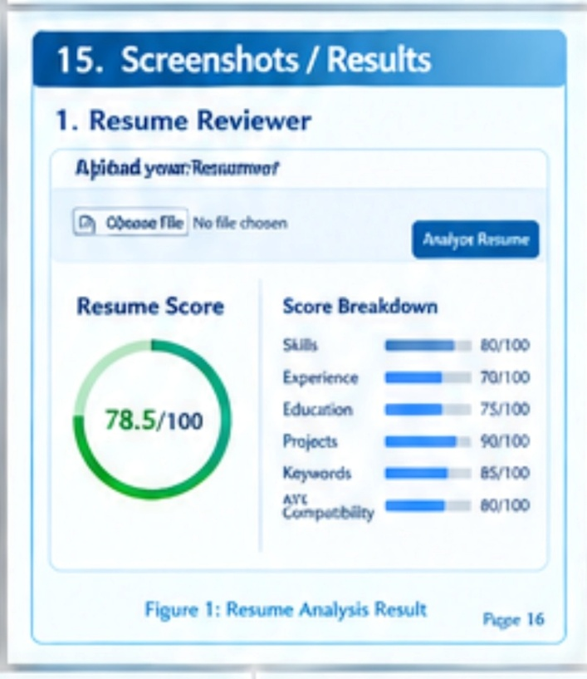
14.Testing
Test cases
Feature | Status
PDF Upload
Text Extraction
Skills Extraction
Education
Experience Analysis
Project Analysis
Keyword Analysis
ATS Compatibility
Resume Core
Job Matching
Visualization
Stream lit App

15.Advantages
- Automates resume analysis
- Provides ATS Compatibility
- Improves ATS compatibility
- Helps with job matching
- Saves time and effort
- User-friendly web interface
16.Conclusion
AI Resume Reviewer is a smart and efficient tool that helps jobs seekers improve their resumes and increase their chances of getting hired. By using NLP, Machine Learning and web technologies the system provides comprehensive analysis, feedback, and job matching. This project demonstrates how AI can solve real-world problems and support career growth.

BY
GUNDLURU ITHIHASIKA
GUNDLURU ITHIHASIKA

